Workshop 4

## Jobprovider - login -joblist

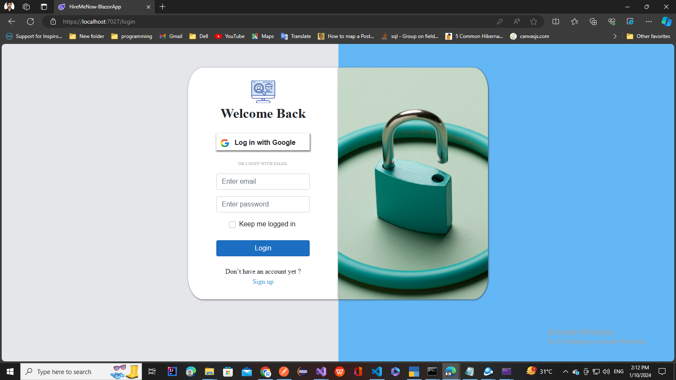

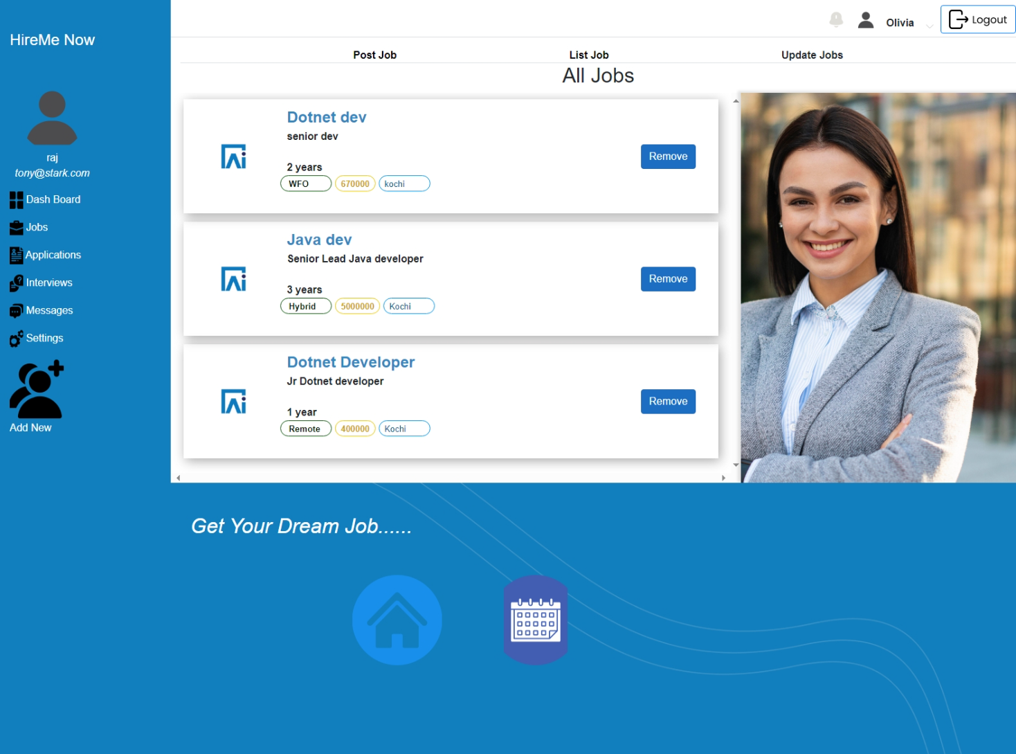

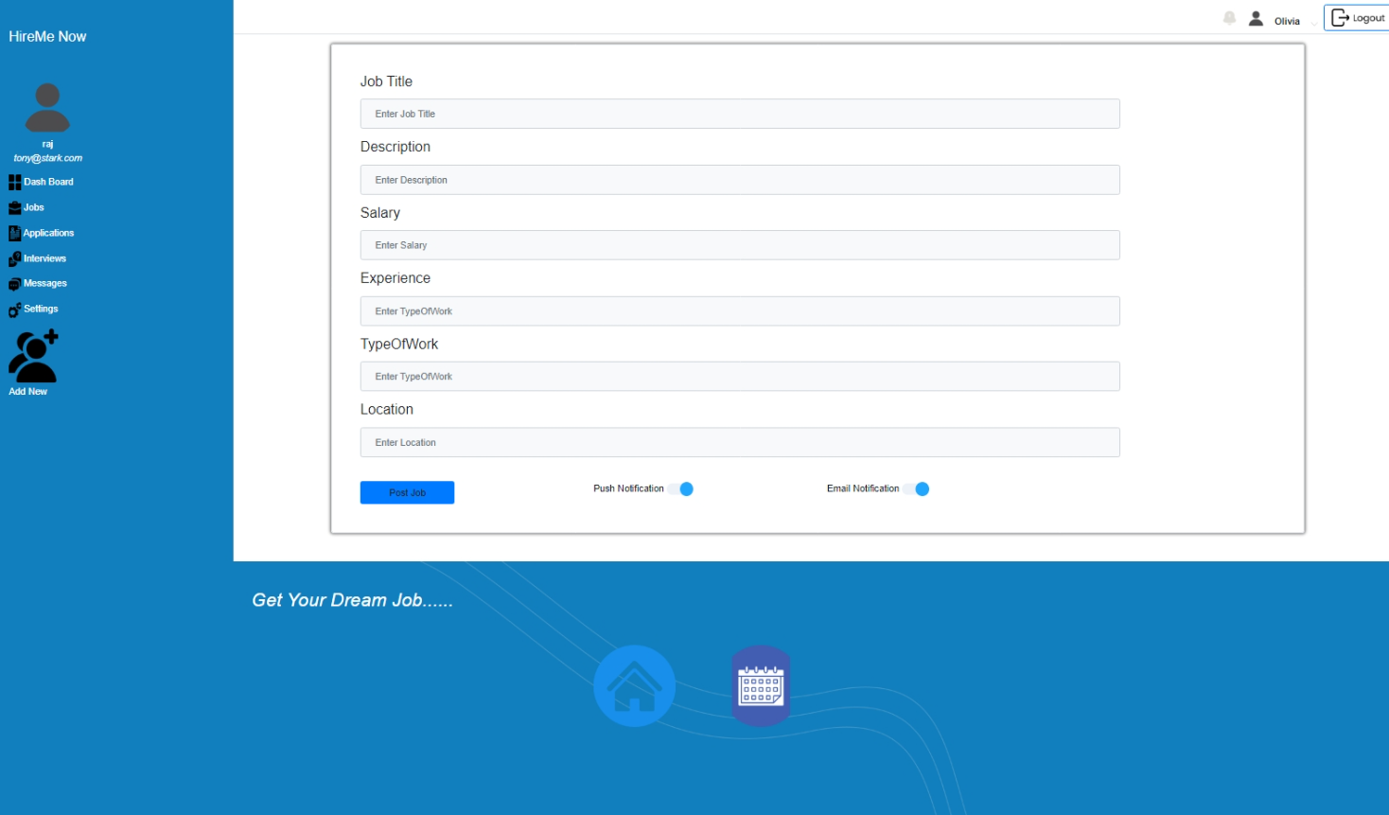

### **Workshop Goals:**

* Understand the basics of EF core
* Learn Communication with database using EF core and LINQ
* Learn EF - DB migration

### **Prerequisites:**

* Basic knowledge of C# and .NET Core
* Familiarity with HTML, CSS, Bootstrap and JavaScript

### **Workshop Agenda:**

#### Part 1: Introduction to EF core

* What is Entity Framework core?
* How to implement Ef in Blazor
* How to Implement CRUD Operation Using EF core

#### Part 2: Setting Up the Project

* Clone the Application and open in Visual studio
* Go through the Project structure overview

#### Part 3: Go through Repository and Check How EF core works

#### Part 4: Add Related Initial Data into the Database

#### Part 5: Implement Update functionality in job list

### **Resources:**

* Visual Studio or Visual Studio Code
* .NET Core SDK